**XSV**

|  |  |
| --- | --- |
| **Summary** | Installed XSV and executing commands |
| **URL** | <https://github.com/BurntSushi/xsv>  <https://drive.google.com/file/d/1NbWYAdTabsWzwNWXXZOULKxDmir8ZRN8/view?usp=sharing> |
| **Tools** | XSV |

XSV Installation

Tried CommanTried Running XSV Commands with XSV

3 Lesson Learned

# 

# **XSV** **Installation**

XSV installation Steps:

* Installed <https://www.rust-lang.org/tools/install>
* cargo install xsv

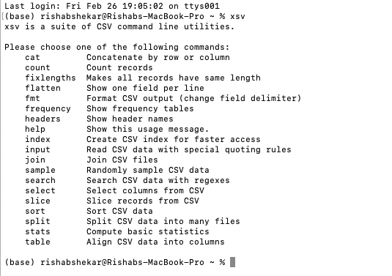

# **Executing XSV Commands**

Below are the Commands that was executed:

* Headers
* Sample
* Stats

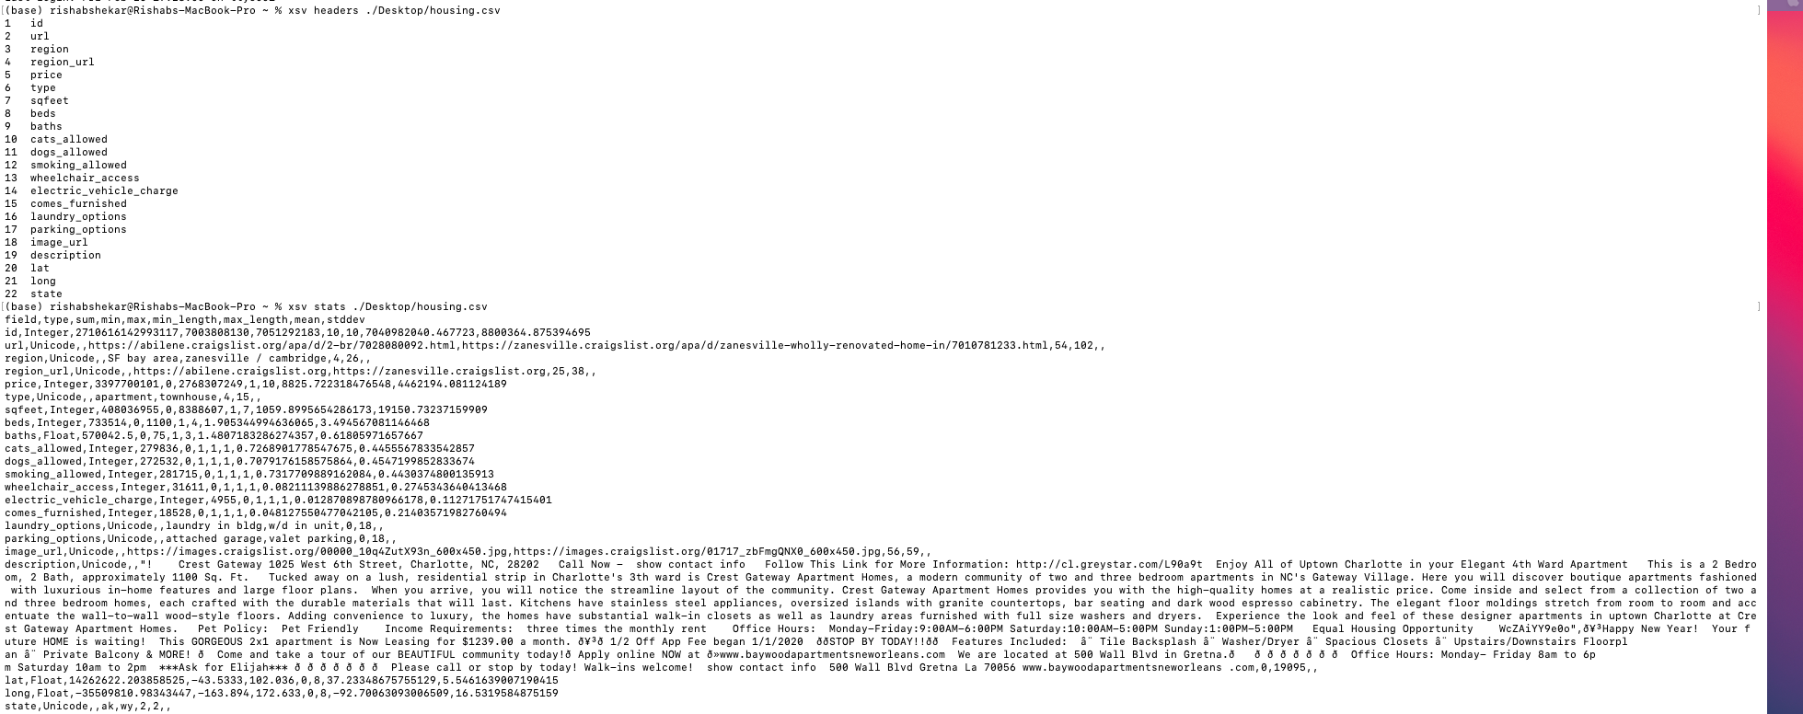

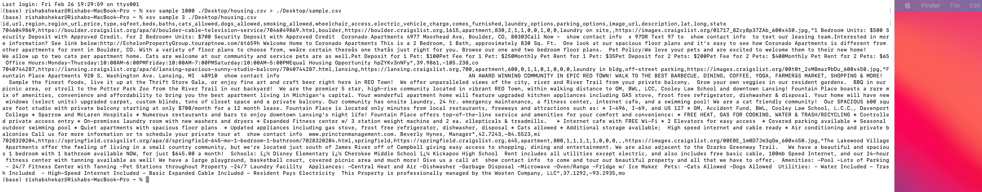

# 3 Lesson Learned

* XSV is a command-line program for indexing, slicing, analyzing, splitting, and joining CSV files.
* The commands are simple, fast and composable.
* Installation is quite easy and straightforward.